Practial:5

Aim:-Study of Hardware components – motherboard, processor, memory(DDR3,DDR4),HDD, DVD writer, NIC

- Motherboard
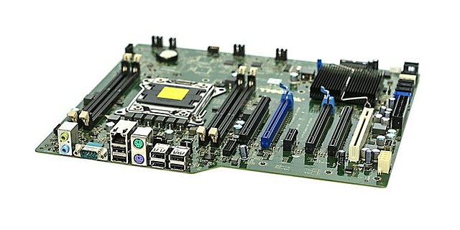
A motherboard is like the central nervous system of a computer. It's the main circuit board that connects all the different parts of a computer system, allowing them to communicate and work together.
A typical computer motherboard contains the following electronic components or parts that are as:
- Chipsets
- CPU or processor sockets or slots
- Memory slots
- Expansion slots
- BIOS chip
- CMOS battery
- Power connectors
- Keyboard and mouse connectors
- Onboard disk drive connectors
- Peripheral ports and connectors
- Jumpers and DIP switches
- Case fan and Heat sink

2.Processor
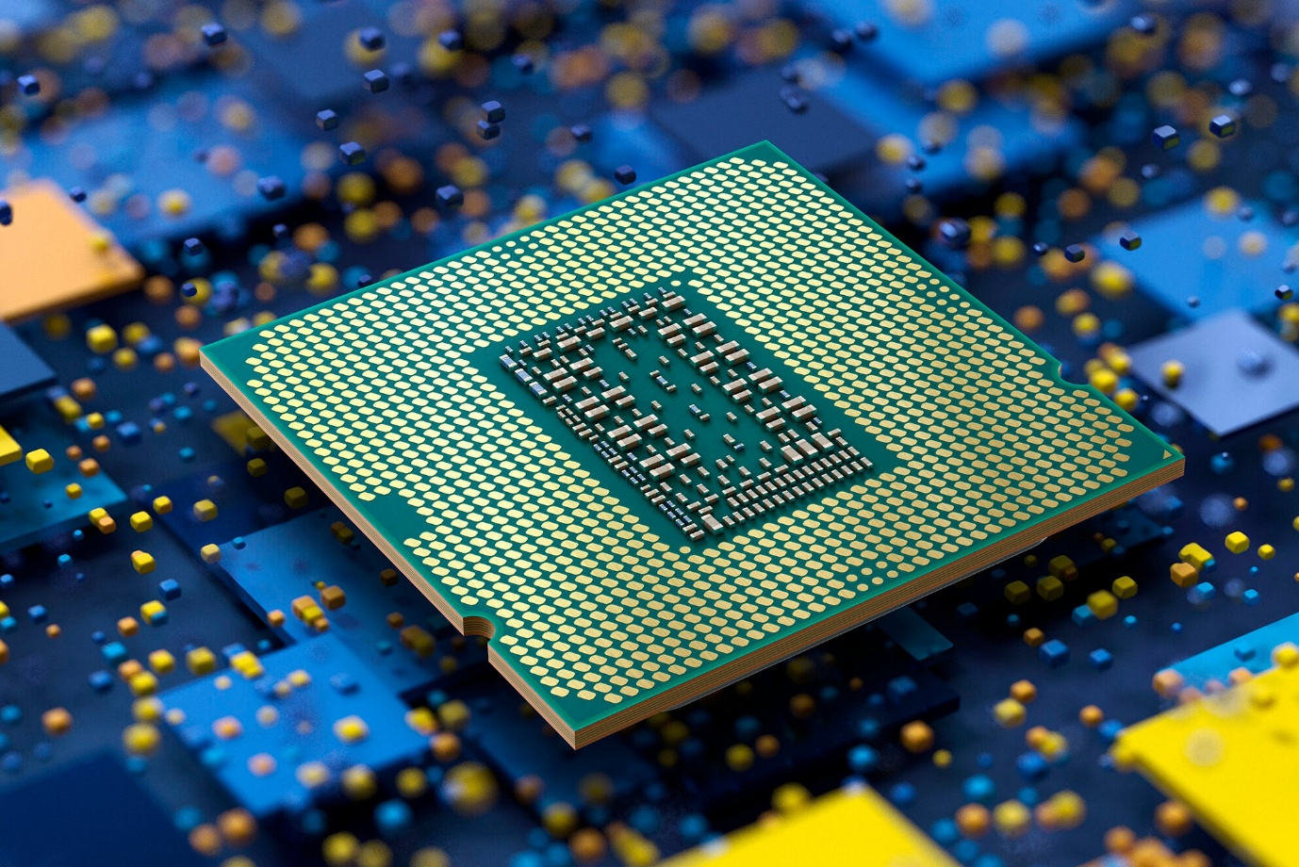
Processors are the most important component of a computer system. A Processor is a hardware that performs data input/output, processing, and storage functions for a computer system. In this article, we are going to discuss processors.
A processor, also known as a central processing unit (CPU), is the "brain" of a computer or other electronic device, responsible for executing instructions and performing calculations that enable the device to function. It interprets and executes commands from software, controlling the overall operations of the system.
Here's a more detailed explanation:
Core Function:
The processor fetches instructions from memory, decodes them, and then executes them, carrying out tasks ranging from simple arithmetic to complex operations.

3.Memory (DDR3, DDR4)

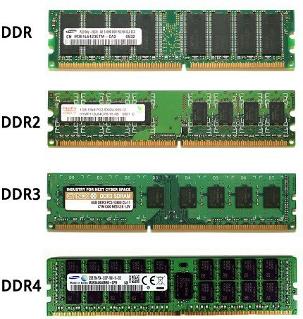

DDR3 and DDR4 are generations of RAM (Random Access Memory) used in computers, with DDR4 being the newer and generally faster and more efficient option. DDR4 offers higher data transfer rates, lower power consumption, and increased memory density compared to DDR3. However, DDR3 is often found in older systems and can be more cost-effective for certain uses.

4. HDD(Hard Disk Drive)

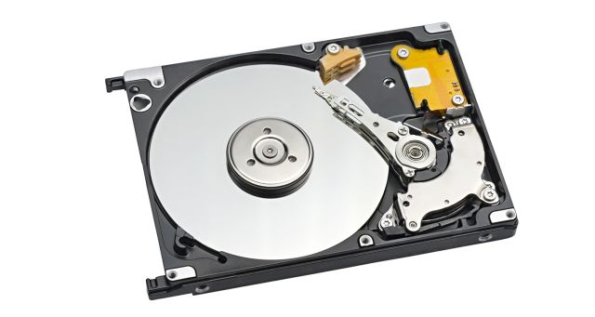
HDD stands for Hard Disk Drive. It is a data storage device that uses magnetic platters to store and retrieve digital information, commonly used in computers and other electronic devices. HDDs are a type of non-volatile storage, meaning they retain data even when the device is powered off.
Key Characteristics of HDDs:
Magnetic Storage: HDDs use rotating platters coated with magnetic material to store data.
Non-Volatile: Data is retained even when the device is not powered on.
Random Access: Data can be accessed in any order, unlike sequential access methods.
Components: HDDs typically include platters, actuator arms, and read/write heads.
Speed: Generally slower than Solid State Drives (SSDs) in terms of data access and transfer rates.
Common Use: Found in desktop computers, laptops, and other devices as a primary or secondary storage option.

5. DVD WRITER

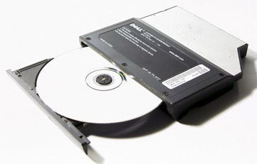

A DVD writer is a computer device that allows users to record data onto DVD discs. It uses laser technology to write information onto the disc, enabling the storage of large files, videos, and other data. DVD writers can be either internal, installed within a computer, or external, connected via USB or other interfaces.
Key aspects of a DVD writer:
Recording capability:
Unlike DVD-ROM drives which only read data, DVD writers can both read and write data onto DVD discs.
Laser technology:
DVD writers use a laser to write data onto the disc by creating microscopic indentations on the disc's surface, which are then interpreted as data.

6. NIC(Network interface card)

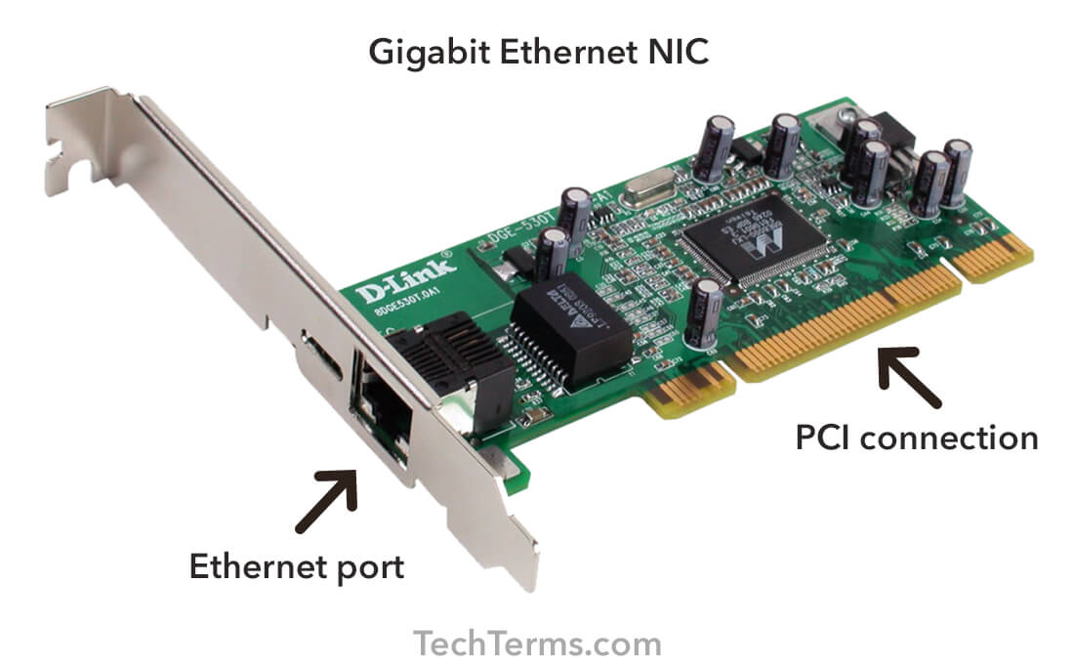
Network Interface Card (NIC):
A NIC is a hardware component that enables a computer to connect to a network.
It acts as an interface between the computer and the network, allowing data to be transmitted and received.
NICs can be wired (using Ethernet cables) or wireless (using Wi-Fi).
They are essential for connecting computers to the internet, local networks, and other devices.

